VN 3.3 Binary Ionic Compounds

A. Making compounds to balance charge
- charges should always add up to ______________
- Add subscripts to show # of ______________
- Write _______________ first and anion second

Ex: Strontium and Fluorine

Ex: Calcium and Phosphorous

B. Naming ionic compounds
- Name the cation first
  - Metals with multiple charges use _____________ numerals to show the charge on the metal Ex: Iron (II) is
- Name the anion second
  - Monatomic - change ending to –____________
  - Polyatomic- name stays the same
- To determine which is the cation and which is the anion, draw a line after the metal or ammonium (NH₄)

Examples
- CaCl₂ _____________________________________________
- NaBr _____________________________________________
- K₃N _____________________________________________

C. Name to Formula
- potassium chloride ________________________________
- magnesium Sulfide ________________________________
- Aluminum oxide ________________________________
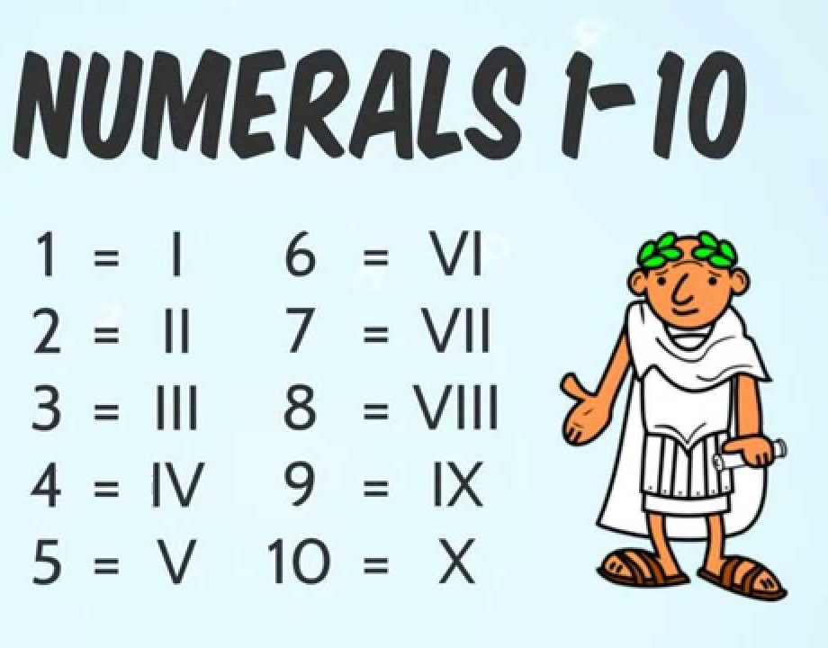
D. Multi-Charge (Transition) Metals
Roman numerals are only used if the metal has more than one possible charge.
Do not use roman numerals for single charge transition metals (ex: AgCl = silver chloride)

Remember the Magic Triangle
If it is a metal (left of the stair case) in group 1A or 2A or in the magic triangle it has only one charge and does not need roman numerals

Examples: Write formula or Name
- Iron (II) Sulfide __________________________
- Gold (III) oxide __________________________
When naming compounds with multi-charge metals, you must work backwards to determine the charge

- CuBr₂
__________________________________________________________

- FeO _____________________________________

- Fe₂S₃ __________________________________________________________

